# ETL Techniques

ETL stands for Extract, Transform, and Load, and refers to the process of curating data from multiple sources, conforming it to a unified data format or structure, and loading the transformed data into its new environment.

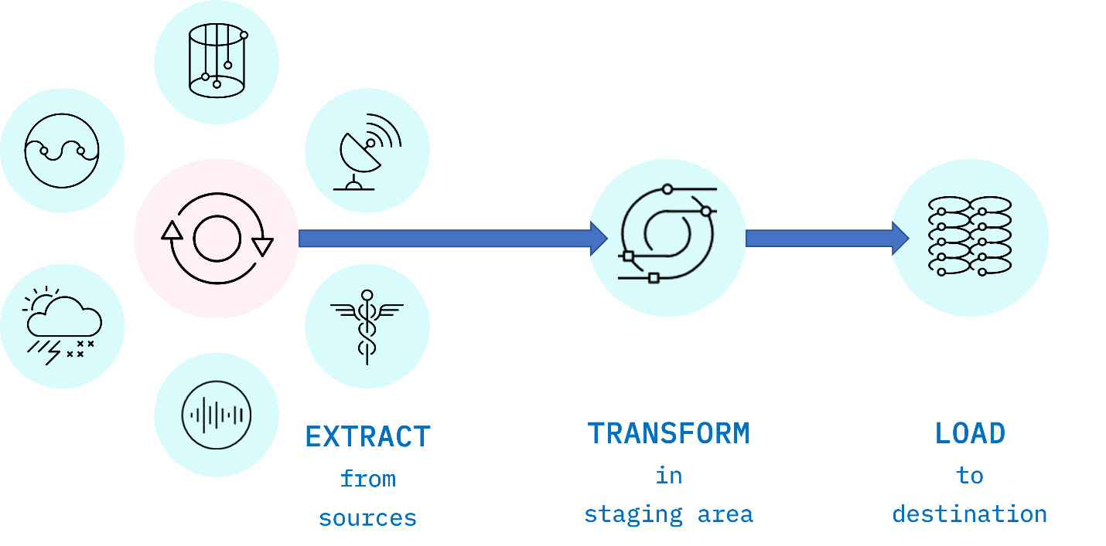

*Fig. 1. ETL is an acronym used to describe the main processes behind a data pipeline design methodology that stands for Extract-Transform-Load. Data is extracted from disparate sources to an intermediate staging area where it is integrated and prepared for loading into a destination such as a data warehouse.*

**Extract**

Data extraction is the first stage of the ETL process, where data is acquired from various source systems. The data may be completely raw, such as sensor data from IoT devices, or perhaps it is unstructured data from scanned medical documents or company emails. It may be streaming data coming from a social media network or near real-time stock market buy/sell transactions, or it may come from existing enterprise databases and data warehouses.

**Transform**

The transformation stage is where rules and processes are applied to the data to prepare it for loading into the target system. This is normally done in an intermediate working environment called a “staging area.” Here, the data are cleaned to ensure reliability and conformed to ensure compatibility with the target system.

Many other transformations may be applied, including:

* Cleaning: fixing any errors or missing values
* Filtering: selecting only what is needed
* Joining: merging disparate data sources
* Normalizing: converting data to common units
* Data Structuring: converting one data format to another, such as JSON, XML, or CSV to database tables
* Feature Engineering: creating KPIs for dashboards or machine learning
* Anonymizing and Encrypting: ensuring privacy and security
* Sorting: ordering the data to improve search performance
* Aggregating: summarizing granular data

**Load**

The load phase is all about writing the transformed data to a target system. The system can be as simple as a comma-separated file, which is essentially just a table of data like an Excel spreadsheet. The target can also be a database, which may be part of a much more elaborate system, such as a data warehouse, a data mart, data lake, or some other unified, centralized data store forming the basis for analysis, modeling, and data-driven decision making by business analysts, managers, executives, data scientists, and users at all levels of the enterprise.

In most cases, as data is being loaded into a database, the constraints defined by its schema must be satisfied for the workflow to run successfully. The schema, a set of rules called integrity constraints, includes rules such as uniqueness, [referential integrity](https://en.wikipedia.org/wiki/Referential_integrity), and mandatory fields. Thus such requirements imposed on the loading phase help ensure overall data quality.

**ETL Workflows as Data Pipelines**

Generally, an ETL workflow is a well thought out process that is carefully engineered to meet technical and end-user requirements.

Traditionally, the overall accuracy of the ETL workflow has been a more important requirement than speed, although efficiency is usually an important factor in minimizing resource costs. To boost efficiency, data is fed through a *data pipeline* in smaller packets (see Figure 2). While one packet is being extracted, an earlier packet is being transformed, and another is being loaded. In this way, data can keep moving through the workflow without interruption. Any remaining bottlenecks within the pipeline can often be handled by parallelizing slower tasks.

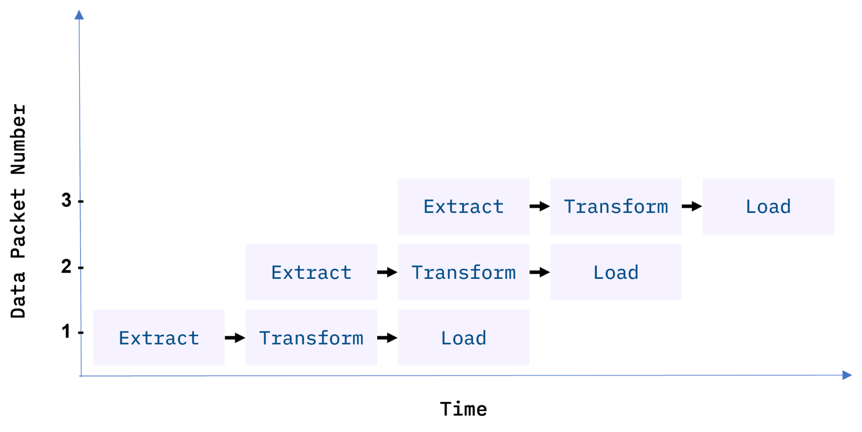

*Fig 2. Data packets being fed in sequence, or “piped” through the ETL data pipeline. Ideally, by the time the third packet is ingested, all three ETL processes are running simultaneously on different packets.*

With conventional ETL pipelines, data is processed in *batches*, usually on a repeating schedule that ranges from hours to days apart. For example, records accumulating in an Online Transaction Processing System (OLTP) can be moved as a daily batch process to one or more Online Analytics Processing (OLAP) systems where subsequent analysis of large volumes of historical data is carried out.

Batch processing intervals need not be periodic and can be triggered by events, such as

* when the source data reaches a certain size, or
* when an event of interest occurs and is detected by a system, such as an intruder alert, or
* on-demand, with web apps such as music or video streaming services

**Staging Areas**

ETL pipelines are frequently used to integrate data from disparate and usually siloed systems within the enterprise. These systems can be from different vendors, locations, and divisions of the company, which can add significant operational complexity. As an example, (see Figure 3) a cost accounting OLAP system might retrieve data from distinct OLTP systems utilized by the separate payroll, sales, and purchasing departments.

ETL pipelines are frequently used to integrate data from disparate and usually *siloed* systems within the enterprise. These systems can be from different vendors, locations, and divisions of the company, which can add significant operational complexity. As an example, (see Figure 3) a cost accounting OLAP system might retrieve data from distinct OLTP systems utilized by the separate payroll, sales, and purchasing departments.

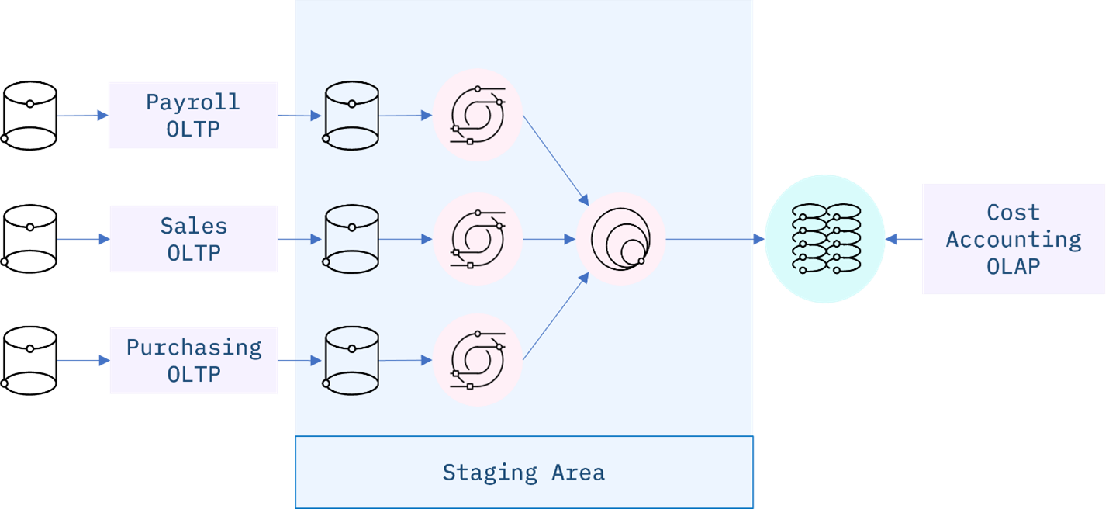

*Fig 3. An ETL data integration pipeline concept for a Cost Accounting OLAP, fed by disparate OLTP systems within the enterprise. The staging area is used in this example to manage change detection of new or modified data from the source systems, data updates, and any transformations required to conform and integrate the data prior to loading to the OLAP.*

**ETL Workflows as DAGs**

ETL workflows can involve considerable complexity. By breaking down the details of the workflow into individual tasks and dependencies between those tasks, one can gain better control over that complexity. Workflow orchestration tools such as Apache Airflow do just that.

Airflow represents your workflow as a directed acyclic graph (DAG). A simple example of an Airflow DAG is illustrated in Figure 4. Airflow tasks can be expressed using predefined templates, called operators. Popular operators include Bash operators, for running Bash code, and Python operators for running Python code, which makes them extremely versatile for deploying ETL pipelines and many other kinds of workflows into production.

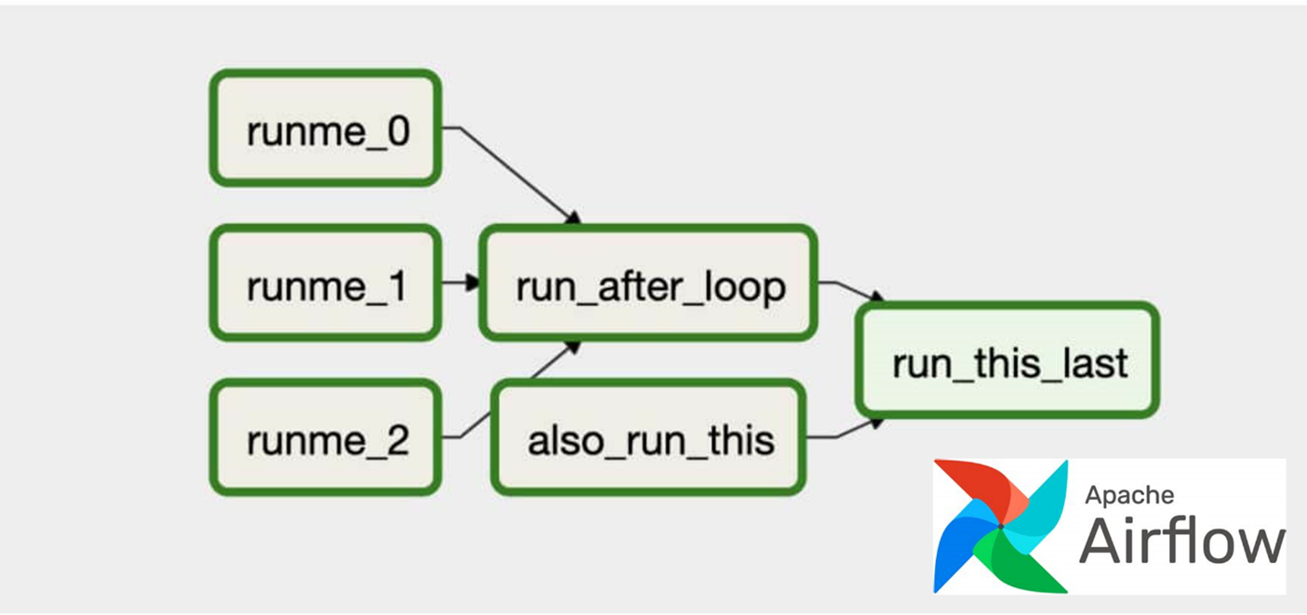

*Fig 4. An Apache Airflow DAG representing a workflow. The green boxes represent individual tasks, while the arrows show dependencies between tasks. The three tasks on the left, ‘runme_j’ are jobs that run simultaneously along with the ‘also_run_this’ task. Once the ‘runme_j’ tasks complete, the ‘run_after_loop’ task starts. Finally, ‘run_this_last’ engages once all tasks have finished successfully.*

**Popular ETL tools**

There are many ETL tools available today. Modern enterprise grade ETL tools will typically include the following features:

* Automation: Fully automated pipelines
* Ease of use: ETL rule recommendations
* Drag-and-drop interface: “o-code” rules and data flows
* Transformation support: Assistance with complex calculations
* Security and Compliance: Data encryption and HIPAA, GDPR compliance

Some well-known ETL tools are listed below, along with some of their key features. Both commercial and open-source tools are included in the list.



**Talend Open Studio**

* Supports big data, data warehousing, and profiling
* Includes collaboration, monitoring, and scheduling
* Drag-and-drop GUI for ETL pipeline creation
* Automatically generates Java code
* Integrates with many data warehouses
* Open-source



**AWS Glue**

* ETL service that simplifies data prep for analytics
* Suggests schemas for storing your data
* Create ETL jobs from the AWS Console



**IBM InfoSphere DataStage**

* A data integration tool for designing, developing, and running ETL and ELT jobs
* The data integration component of IBM InfoSphere Information Server
* Drag-and-drop graphical interface
* Uses parallel processing and enterprise connectivity in a highly scalable platform



**Alteryx**

* Self-service data analytics platform
* Drag-and-drop accessibility to ETL tools
* No SQL or coding required to create pipelines



**Apache Airflow and Python**

* Versatile “configuration” as code data pipeline platform
* Open-sourced by Airbnb
* Programmatically author, schedule, and monitor workflows
* Scales to Big Data
* Integrates with cloud platforms



**The Pandas Python library**

* Versatile and popular open-source programming tool
* Based on data frames – table-like structures
* Great for ETL, data exploration, and prototyping
* Doesn’t readily scale to Big Data

**ETL using Shell Scripting**

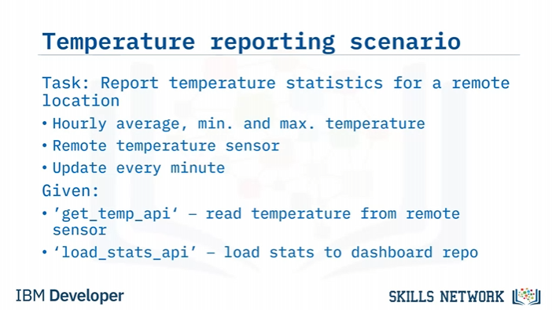

Example workflow

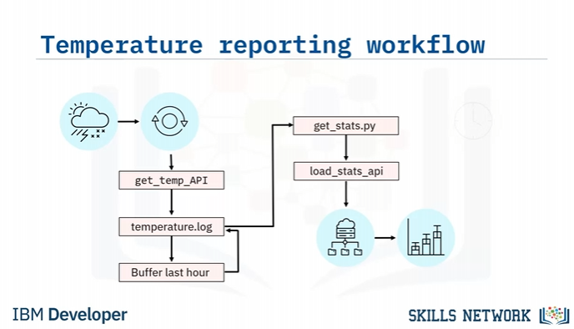

Let's sketch the workflow for your ETL pipeline,

starting with the weather station and its data interface.

The extraction step involves obtaining a current temperature reading from the sensor

using the supplied ‘get_temp’ API.

You can append the reading to a log file, say ‘temperature.log’. Since you will

only need to keep the most recent hour of readings,

buffer the last 60 readings, and then just

overwrite the log file with the buffered readings.

Next, call a program, for example, a python script called ‘get_stats.py’, which calculates

the temperature stats from the 60-minute log, and

loads the resulting stats into the reporting system using the load_stats API.

The stats can then be used to display a live chart showing the hourly min, max

and average temperatures.

You will also want to schedule your workflow to run every minute.

Create an ETL Shell Script

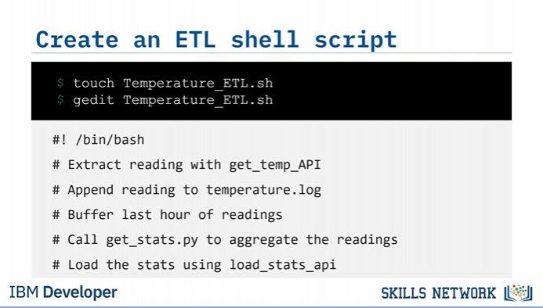

Data extraction and buffer

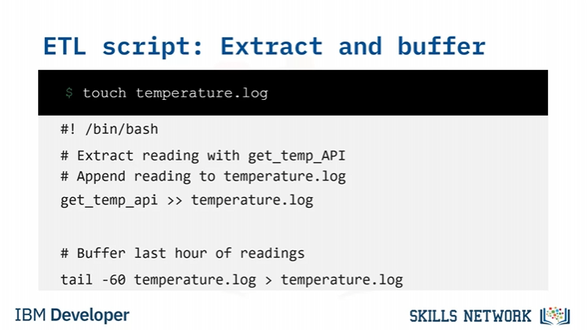

Transform temperatures

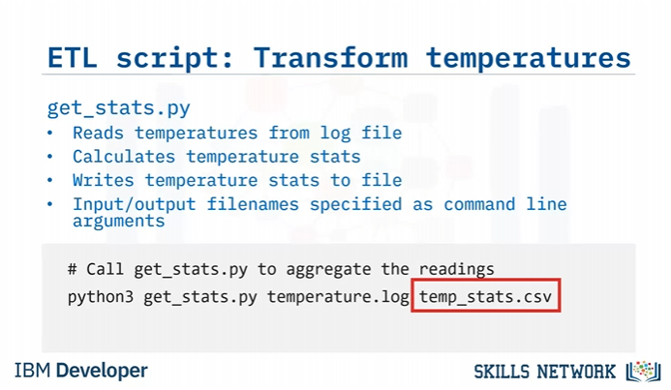

Load the transformed data

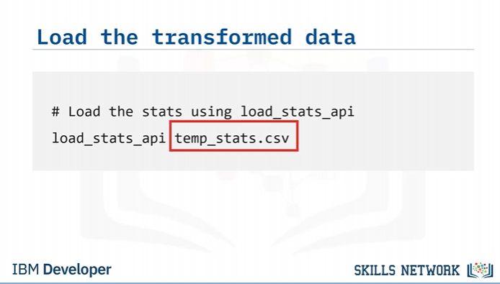

Set permissions

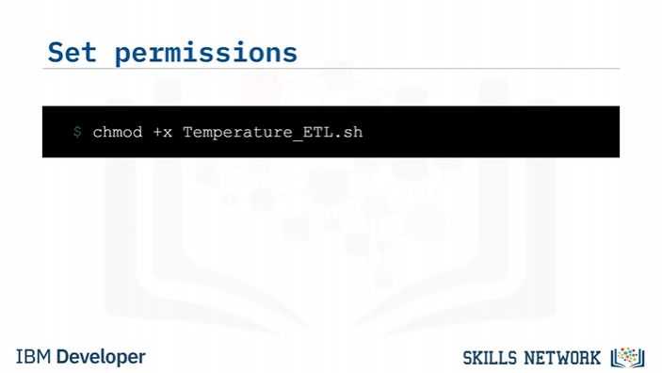

Schedule your ELT Job

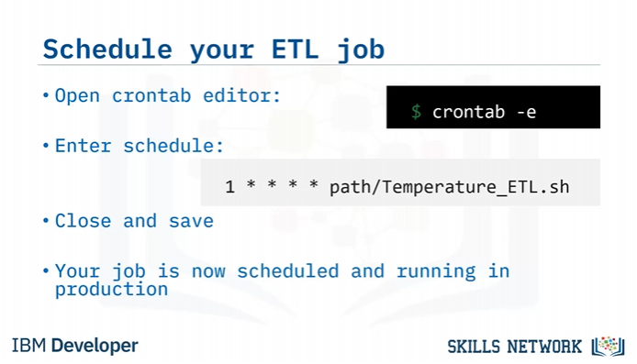

LAB Instructions

**Exercise 1 - Extracting data using cut command**

The filter command cut helps us extract selected characters or fields from a line of text.

**1.1 Extracting characters.**

The command below shows how to extract the first four characters.

1. 1
2. echo "database" | cut -c1-4

Copied!

You should get the string ‘data’ as output.

The command below shows how to extract 5th to 8th characters.

1. 1
2. echo "database" | cut -c5-8

Copied!

You should get the string ‘base’ as output.

Non-contiguous characters can be extracted using the comma.

The command below shows how to extract the 1st and 5th characters.

1. 1
2. echo "database" | cut -c1,5

Copied!

You get the output : ‘db’

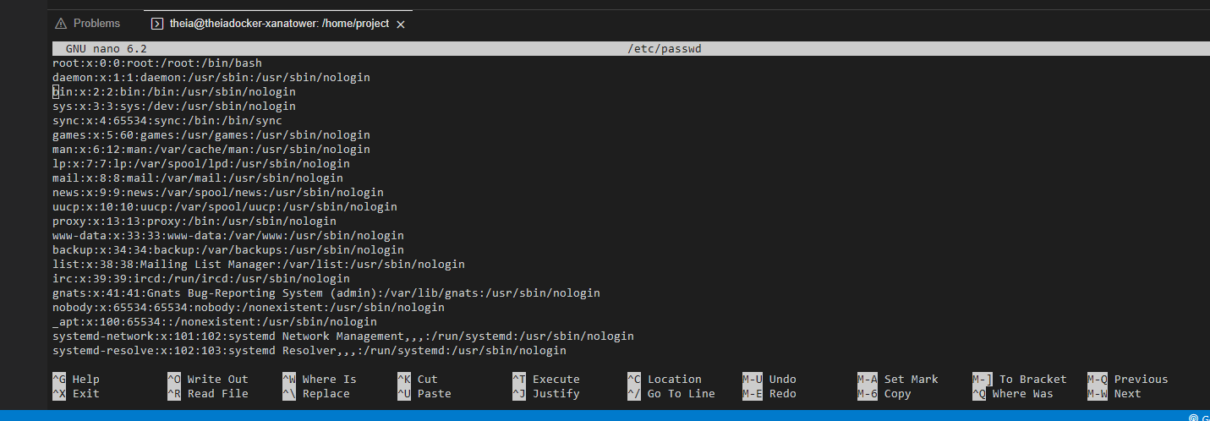

**1.2. Extracting fields/columns**

We can extract a specific column/field from a delimited text file, by mentioning

* the delimiter using the -d option, or
* the field number using the -f option.

The /etc/passwd is a “:” delimited file.

The command below extracts user names (the first field) from /etc/passwd.

cut -d":" -f1 /etc/passwd

The command below extracts multiple fields 1st, 3rd, and 6th (username, userid, and home directory) from /etc/passwd.

cut -d":" -f1,3,6 /etc/passwd

The command below extracts a range of fields 3rd to 6th (userid, groupid, user description and home directory) from /etc/passwd.

cut -d":" -f3-6 /etc/passwd

(Lab not done yet)

## Introduction to Data Pipelines

what is a pipeline

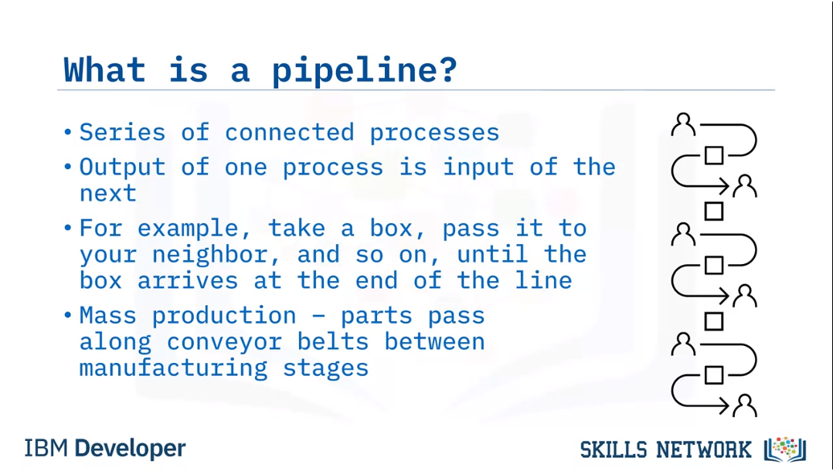

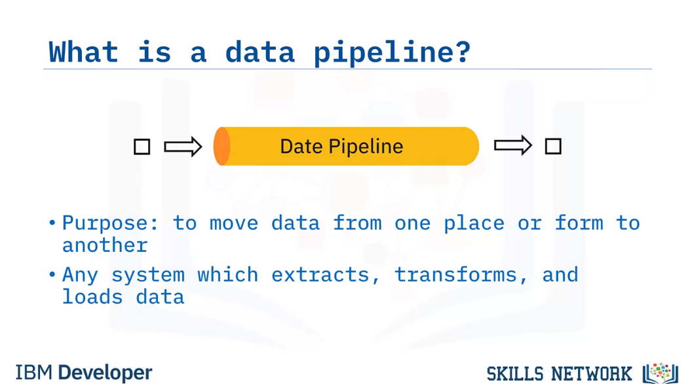

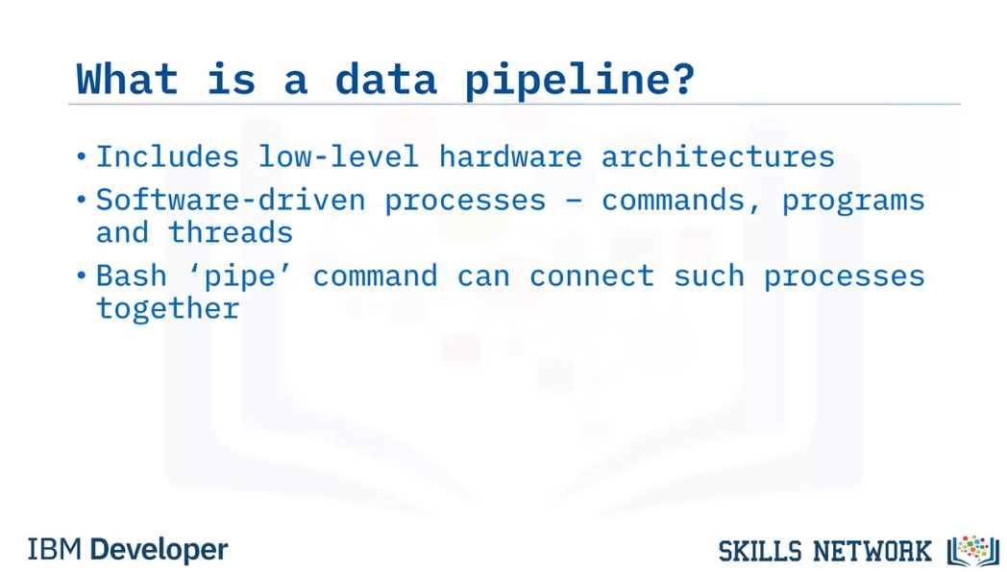

Packet flow through a pipeline

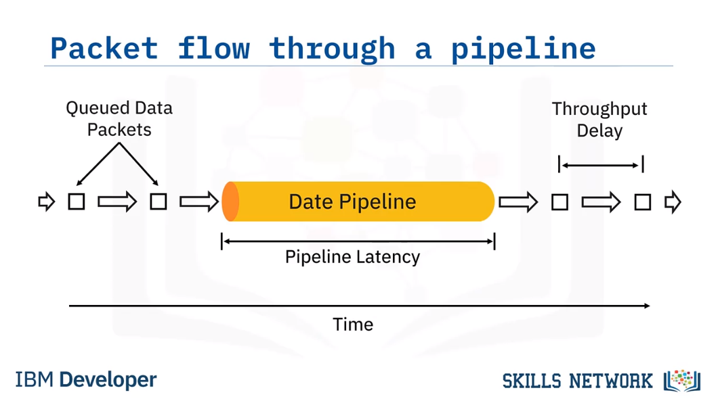

We can think of data flowing through a pipeline in the form of data packets,

a term which we will use to broadly refer to units of data.

Packets can range in size from a single record, or event, to large collections of data.

Here, we have data packets queued for ingestion to the pipeline.

The length of the data pipeline represents the time it takes for

a single packet to traverse the pipeline.

The arrows between packets represent the

throughput delays, or the times between successive packet arrivals.

You have just been introduced to two key

performance considerations regarding data pipelines.

Latency

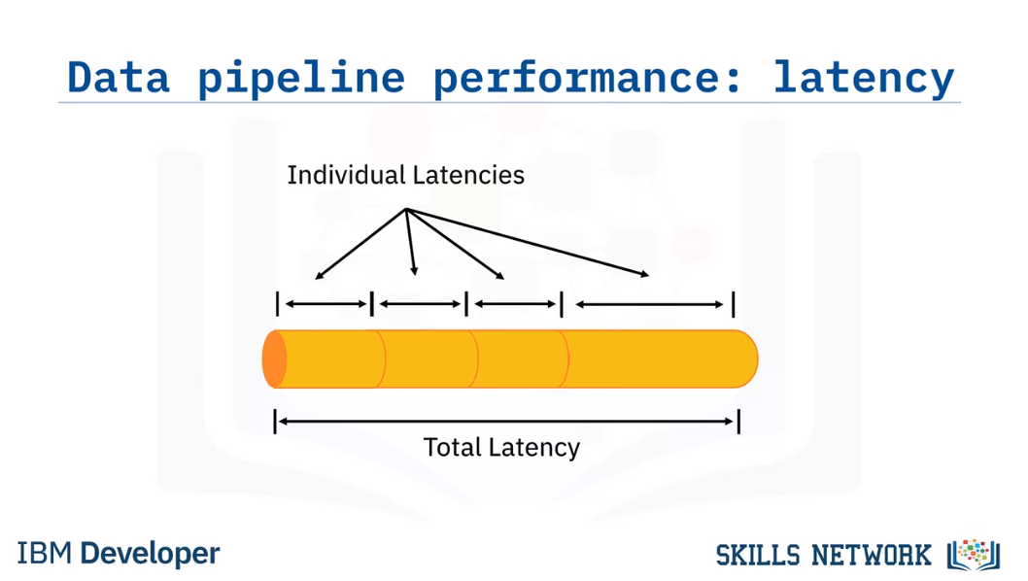

The first is latency, which is the total time it takes for a single

packet of data to pass through the pipeline.

Equivalently, latency is the sum of the individual times

spent during each processing stage within the pipeline.

Thus overall latency is limited by the slowest process in the pipeline.

For example, no matter how fast your internet service is,

the time it takes to load a web page will be decided by the server's speed.

Throughput

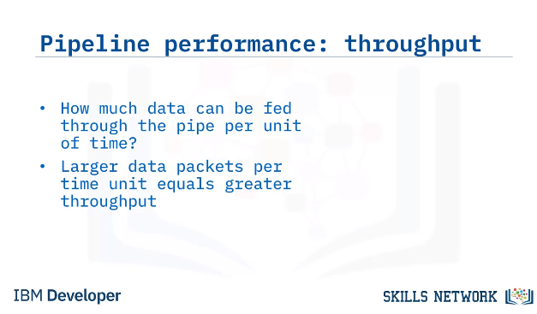

Example

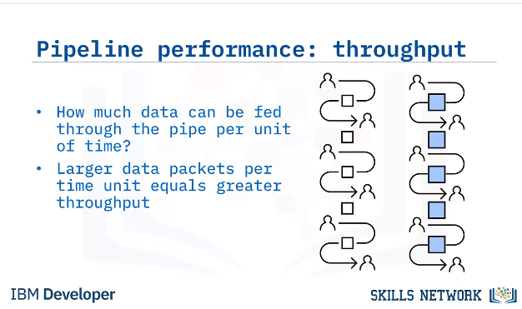

Coming back to our example of having a chain of friends passing boxes from one to another,

we can see in the right image, within limits, that passing bigger boxes can increase productivity.

Use Cases

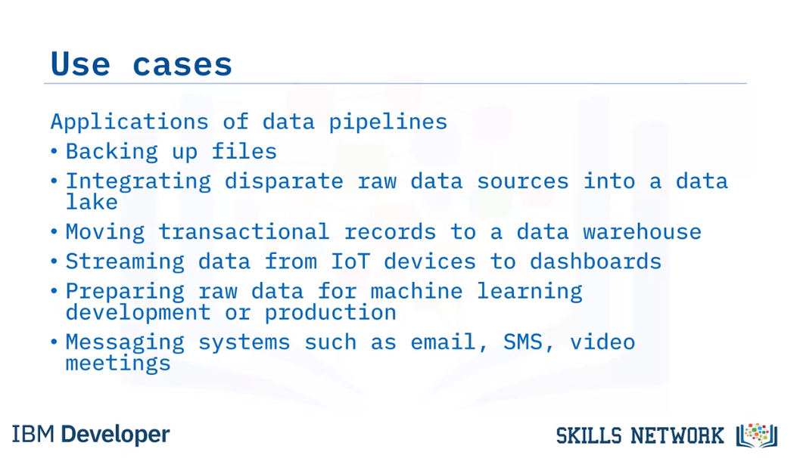

## Key Data Pipeline Processes

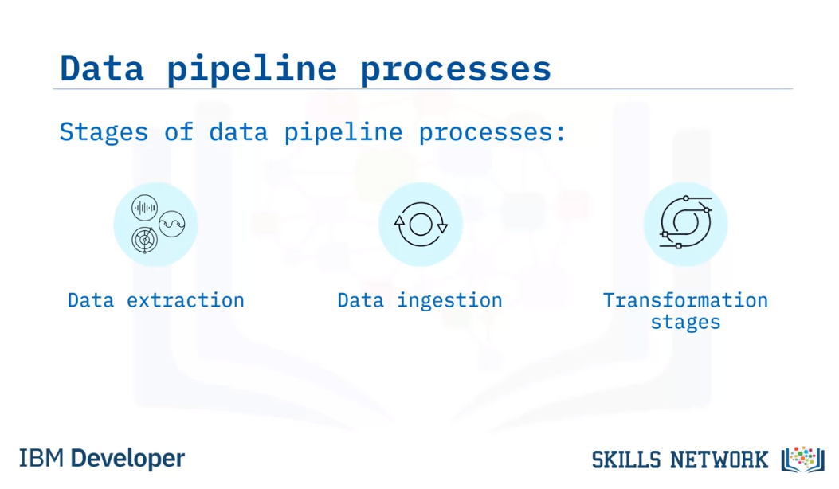

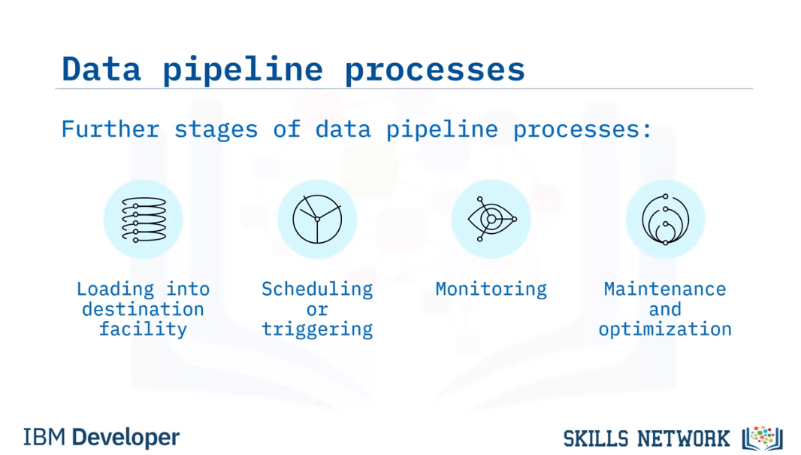

Data pipeline processes typically have the following stages in common:

Extraction of data from one or more data sources.

Ingestion of the extracted data into the pipeline.

Optional data transformation stages within the pipeline, and

Final loading of the data into a destination facility.

A mechanism for scheduling or triggering jobs to run.

Monitoring the entire workflow, and

Maintenance and optimization as required to keep the pipeline up and running smoothly.

**Monitoring**

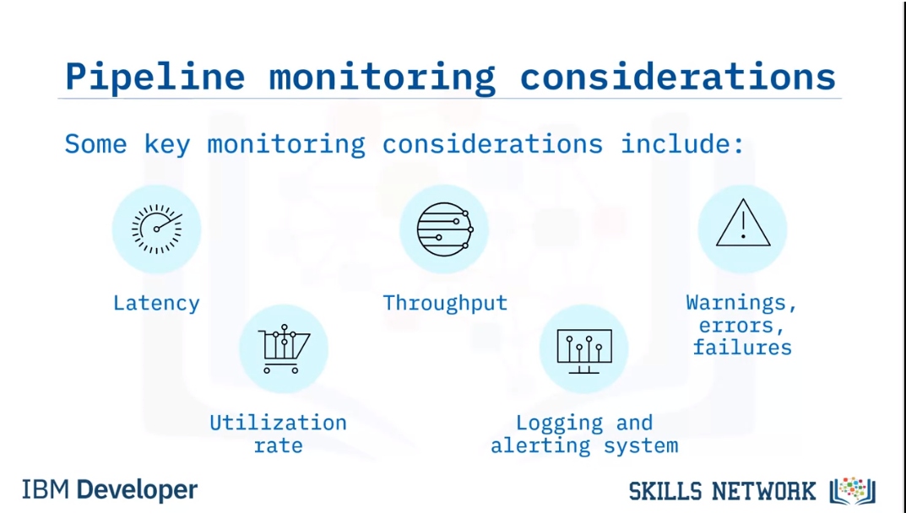

The data pipeline needs to be monitored once it is in production to ensure data integrity.

Some key monitoring considerations include:

Latency, or the time it takes for data packets to flow through the pipeline.

Throughput demand, the volume of data passing through the pipeline over time.

Errors and failures, caused by factors such as network overloading,

and failures at the source or destination systems.

Utilization rate, or how fully the pipeline's resources are being utilized, which affects cost.

Lastly, the pipeline should also have a system for logging events

and alerting administrators when failures occur.

**Load balanced pipelines**

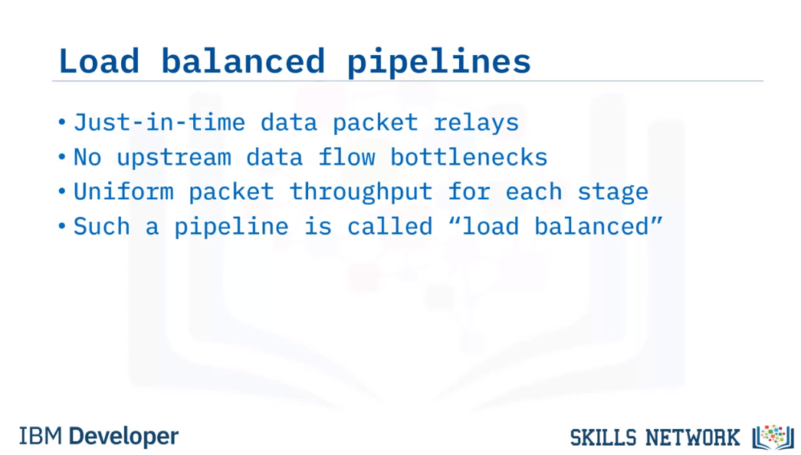

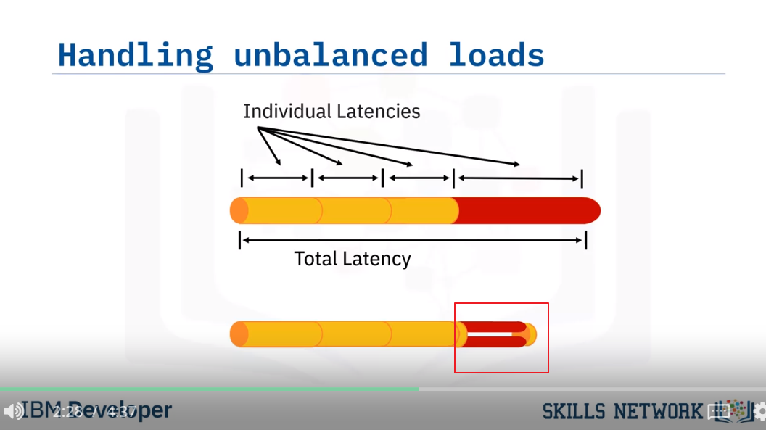

Paramellise the bottleneck

There will be overhead on the

Handling unbalanced loads

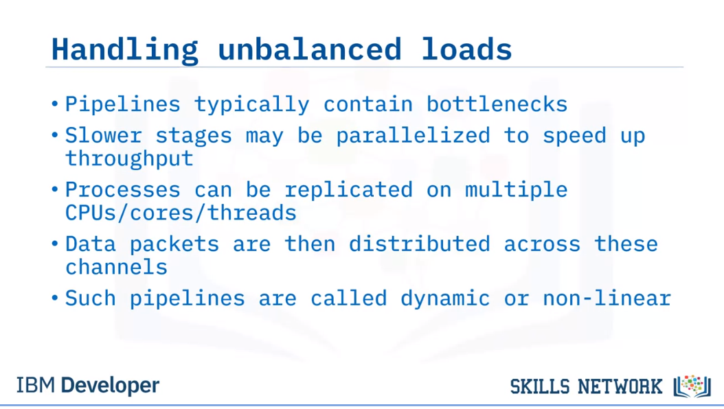

Stage Synchronisation

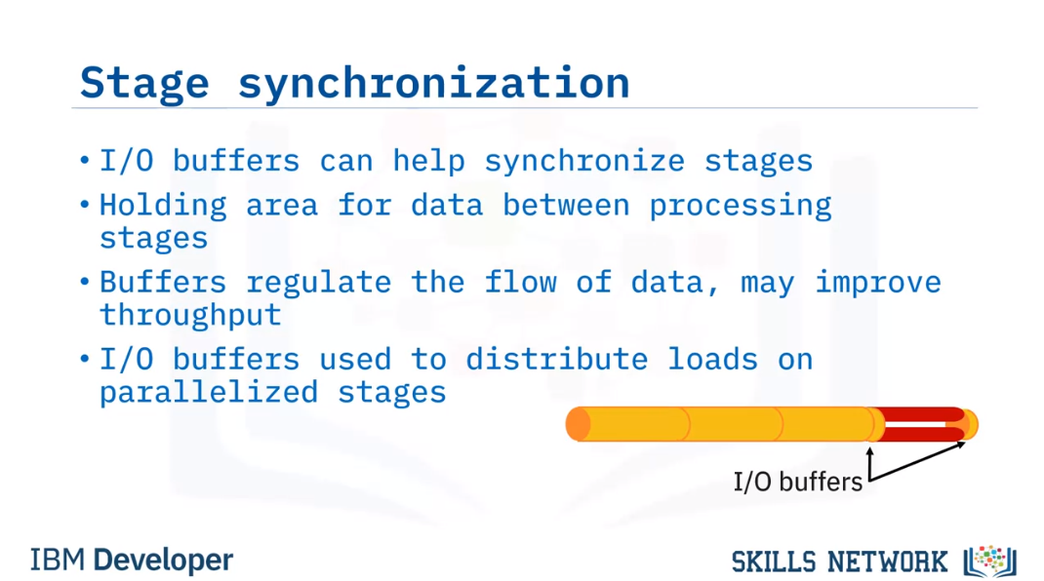

## Batch Versus Streaming Data Pipeline Use Cases

Batch data pipelines

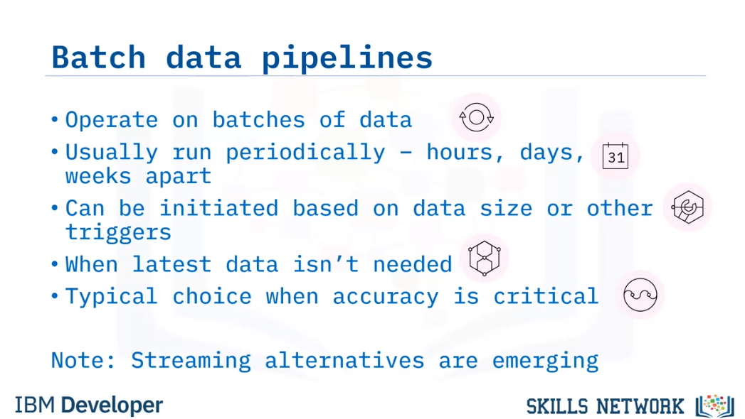

Streaming Data Pipelines

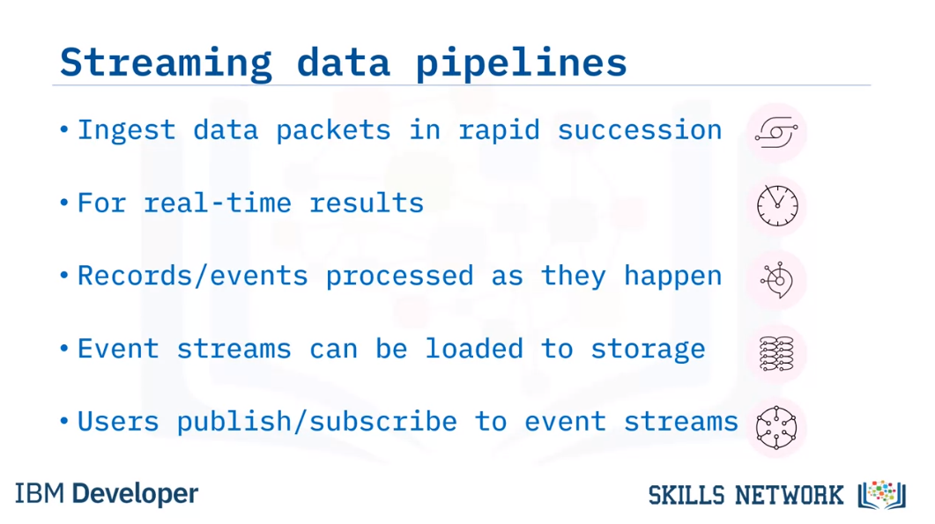

Micro-batch data pipelines

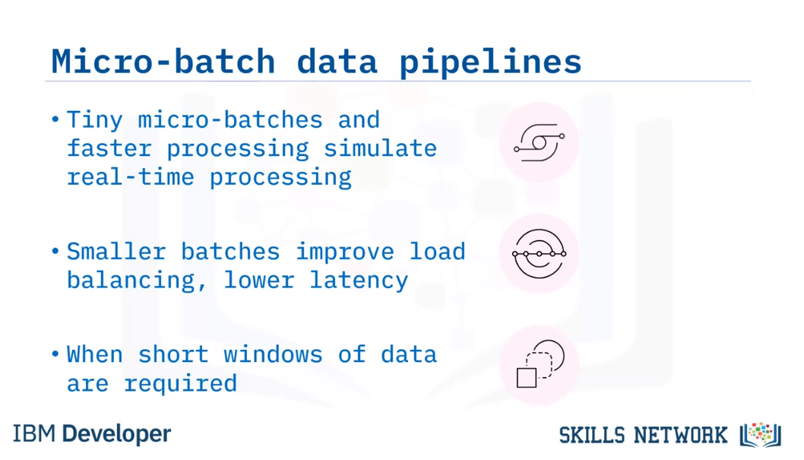

Batch vs stream requirements

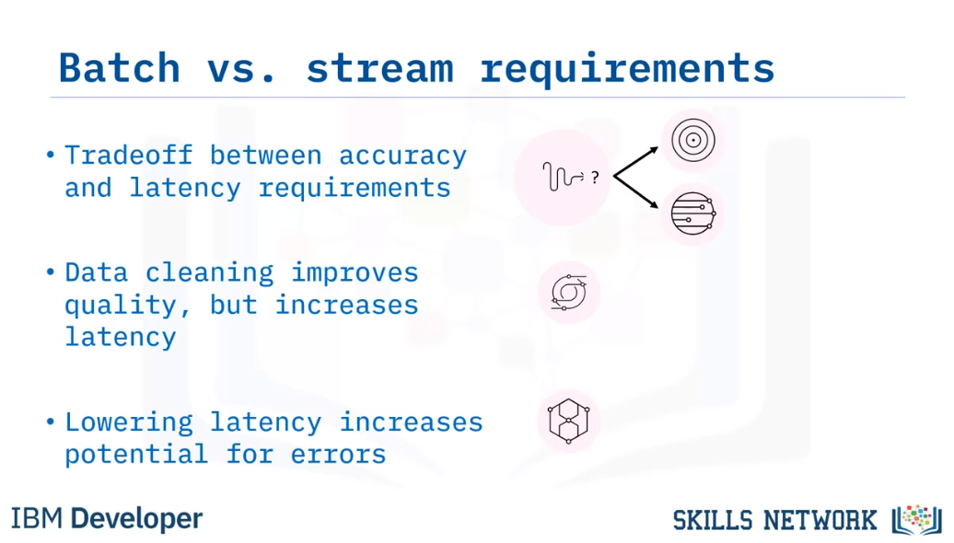

Lambda Architecture

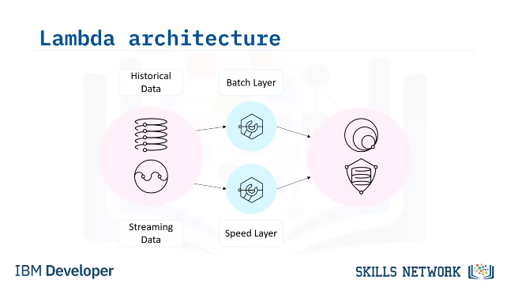

A Lambda architecture is a hybrid architecture, designed for handling Big Data.

Lambda architectures combine batch and streaming data pipeline methods.

Historical data is delivered in batches to the batch layer, and real-time data is

streamed to a speed layer. These two layers are then integrated in the serving layer.

The data stream is used to fill in the “latency gap” caused by the processing in the batch layer.

Lambda can be used in cases where access to earlier data

is required but speed is also important.

A downside to this approach is the complexity involved in the design.

You usually choose a Lambda architecture when you are aiming for accuracy and speed.

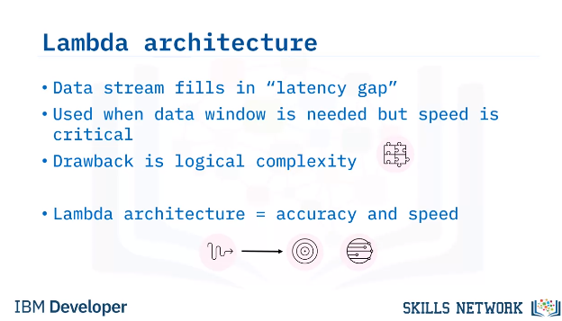

Batch Data pipeline use cases

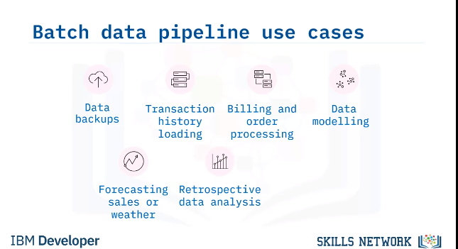

Stream data pipeline use cases

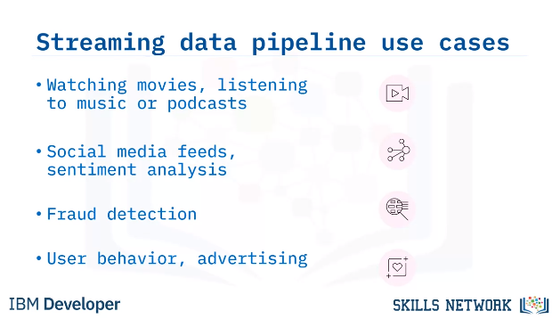

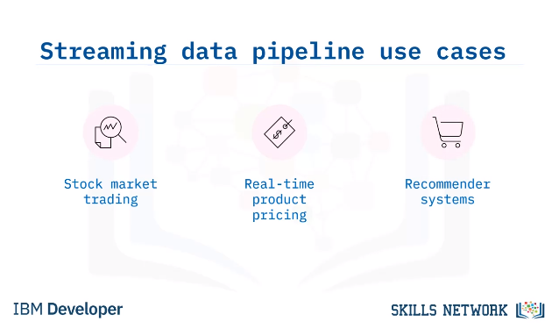

## **Data Pipeline Tools and Technologies**

Features of modern pipeline tools

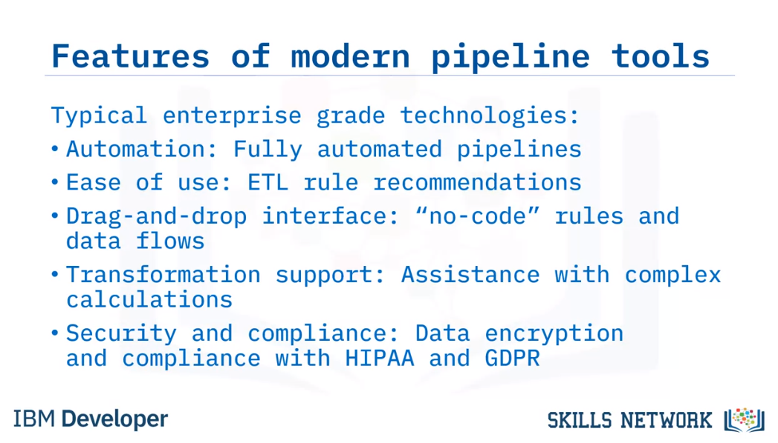

Open Source Data pipeline tools

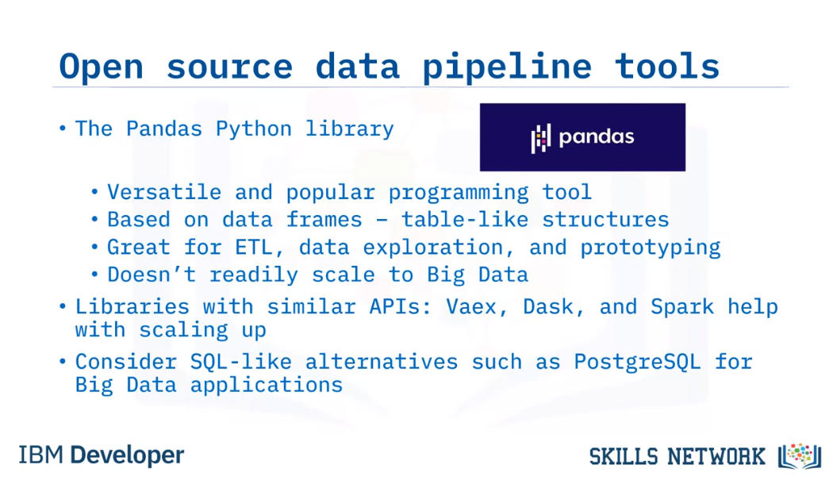

Airflow

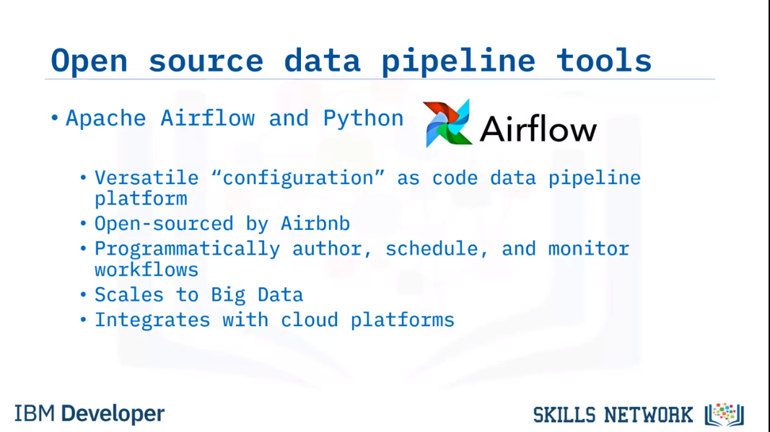

Talend

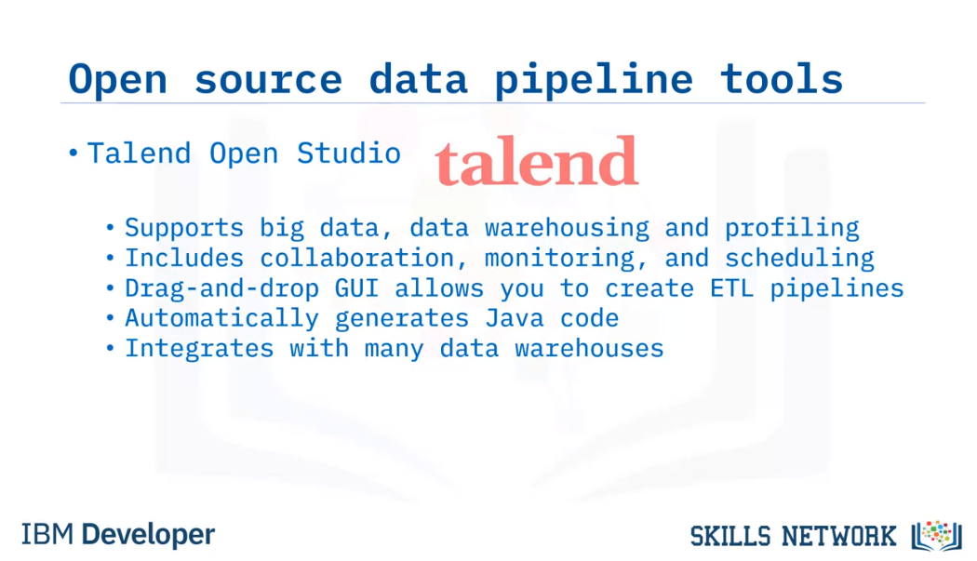

Enterprise data pipeline tools

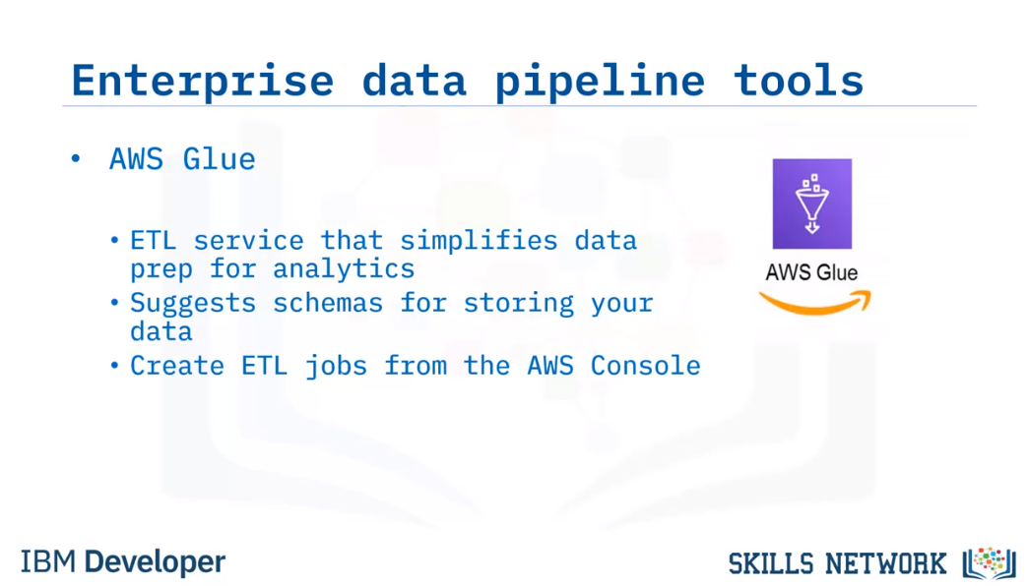

Panoply – ELT

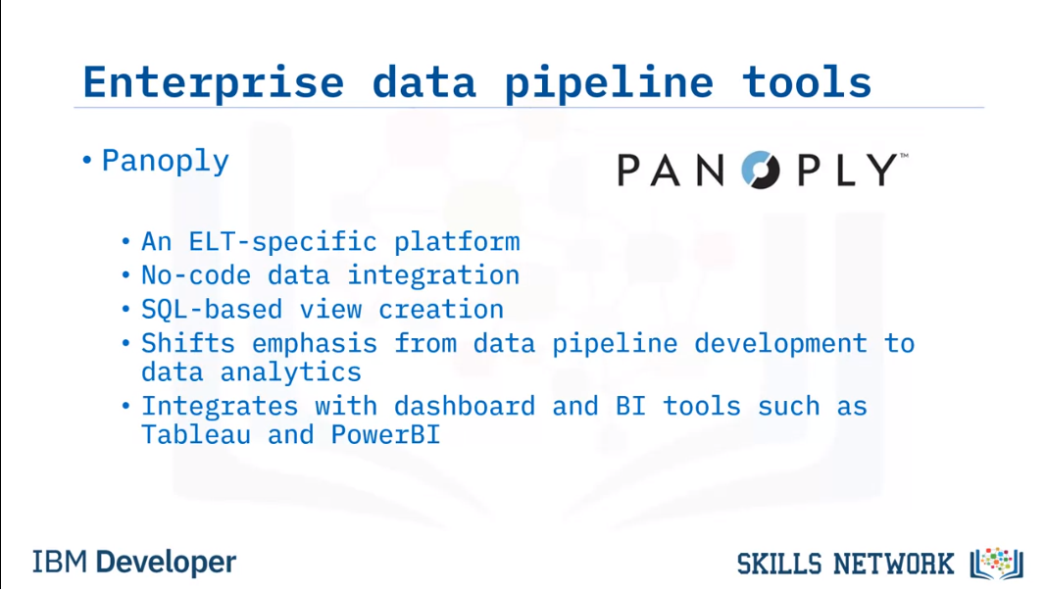

Alteryx

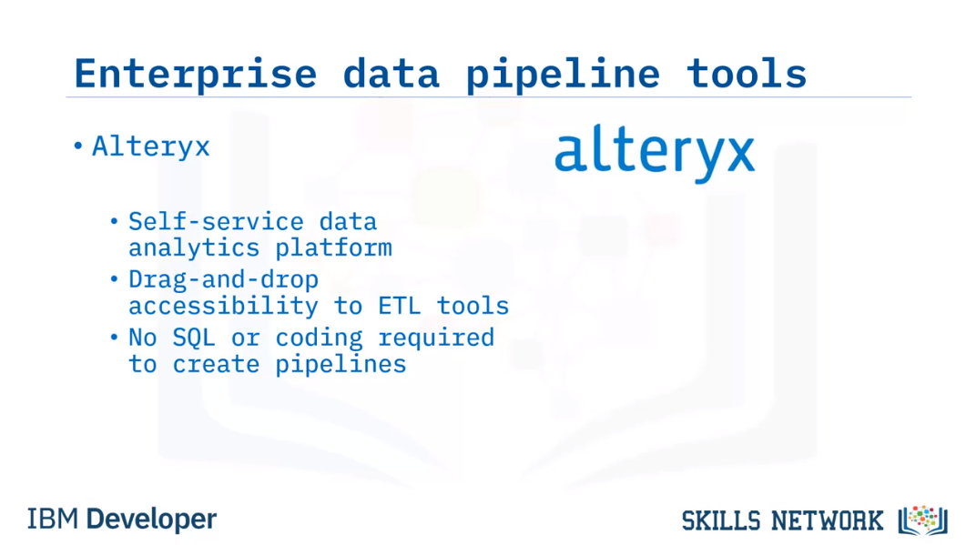

IBM Infosphere

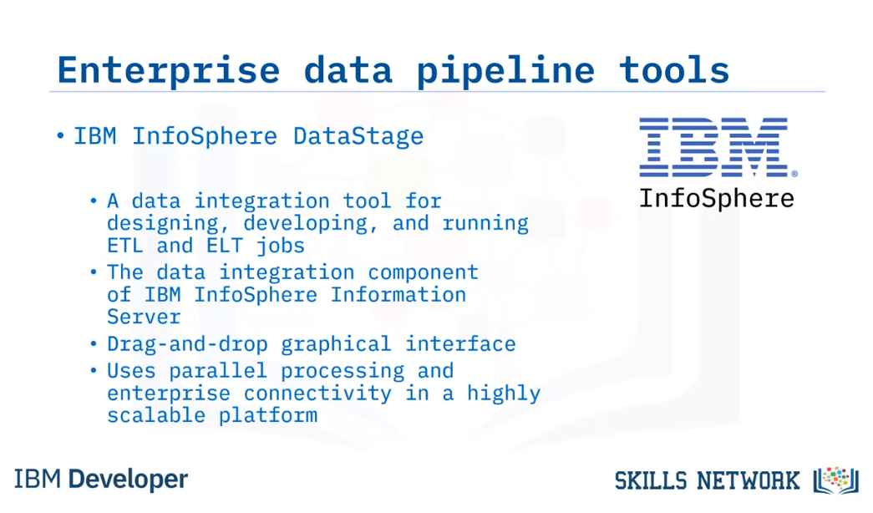

IBM Streams

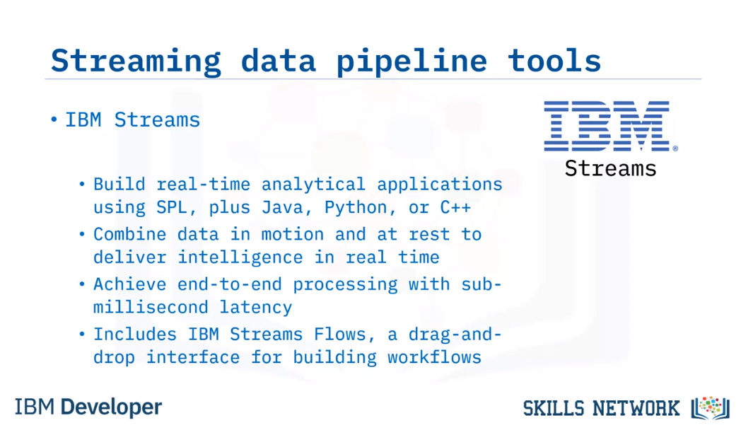

More streaming data pipeline tools

